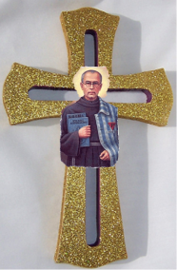
ST. MAXIMILIAN KOLBE PARISH
Kingston – Marsden – Loganlea – Crestmead – Waterford – Logan Reserve-Yarrabilba

SACRAMENTAL PROGRAM 2020: SACRAMENT OF CONFIRMATION FORM

CHILD’S DETAILS
Full Name of Child
(as on the birth certificate)
Home Address
School Attending |  | School Year
Date of Birth |  | Place of Birth
Date of Baptism |  | Place of Baptism

DETAILS OF PARENTS / GUARDIANS
Details | Father | Mother | Guardian
Name
Religion
Phone/Mobile

DETAILS FOR CONFIRMATION

Do you give permission for St. Maximilian Kolbe Parish to use a photograph of your child in the Parish or on the Parish Website.

Yes No

Choice of Child’s  Confirmation Name | (Please select a Saint’s name from list on the reverse side of this page)
Name of Sponsor |  | Religion

We do hereby consent to the receiving the Sacrament of Confirmation of our son/daughter according to the Rites of the Catholic Church.

………………………........................
Parent(s)/ Guardian’s Signatures
Parish Office
Date of Receipt of Form: ..........................
Received by:..............................................
Requirements:

1. Copy of Baptism Certificate of the candidate

2. $25.00 fee/donation for materials and paper work for the Program

